Self- assessment
Peer assessment
Teacher assessment
Tuesday 24th March 2020
WALT: Know a fact is true (Blue and Orange)
Look at the image below and create 3 facts as a group.
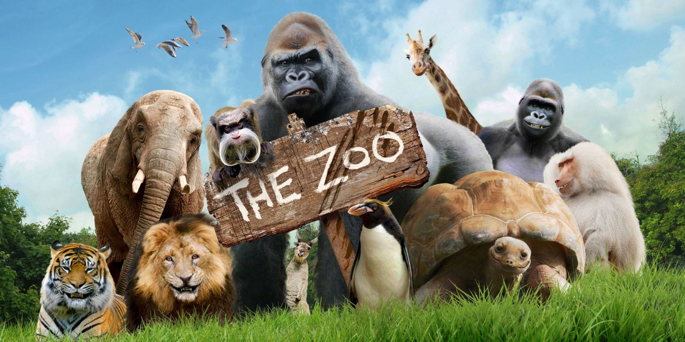

Tuesday 24th March 2020
Self- assessment
Peer assessment
Teacher assessment

WALT: Know a fact is true (Blue and Orange)
Look at the image below and create 3 facts as a group.
Tuesday 24th March 2020
Self- assessment
Peer assessment
Teacher assessment
WALT: Know a fact is true (Red and Green)
Look at the image below and write 3 facts linked to it.
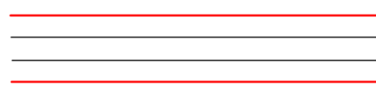
Challenge- Write a sentence that is not a fact.

Tuesday 24th March 2020
Self- assessment
Peer assessment
Teacher assessment
WALT: Know a fact is true (Yellow)
Choose a topic from the list below and write 3 facts about it. Challenge yourself by writing a sentence which is not a fact.
Animals
School
Family and friends

Tuesday 24th March 2020
Self- assessment
Peer assessment
Teacher assessment
WALT: Know a fact is true (Yellow)
Choose a topic from the list below and write 3 facts about it. Challenge yourself by writing a sentence which is not a fact.
Animals
School
Family and friends

Tuesday 24th March 2020
Self- assessment
Peer assessment
Teacher assessment
WALT: Know a fact is true (Yellow)
Choose a topic from the list below and write 3 facts about it. Challenge yourself by writing a sentence which is not a fact.
Animals
School
Family and friends

