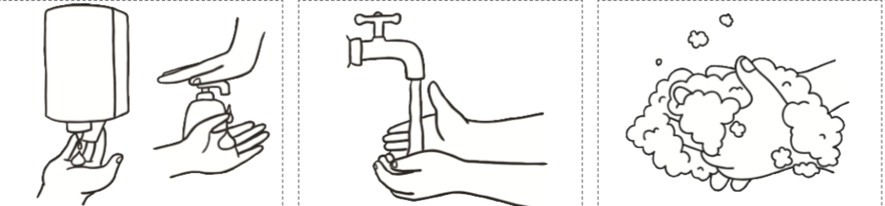

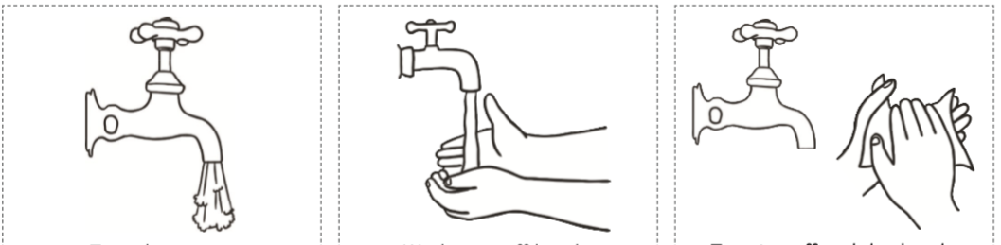

Self-assessment
Peer assessment
Teacher assessment
Thursday 26th March 2020
WALT: Know a temporal conjunction tells us the time it has happened (Blue and Orange)

______________ turn on the tap.
______________ wet your hands under the running water.
______________ squirt the soap onto your hands.
______________ rub your hands together to create a lather, do this for 20 seconds.
______________ rinse the soap off under the running water.
______________ turn the tap off and dry your hands.

First | After that | Finally
A few moments later | Then | Next

