On the following pages, you will find a selection of activities linked to the English learning your child would have been completing at school this week. Please read the instructions carefully and complete the task with your child.
Thank you.

Activity 1- Read the words below the pictures. Together, unscramble the words to make a sentence. Read this aloud. Does it make sense? Use the punctuation to support you when ordering your sentence.

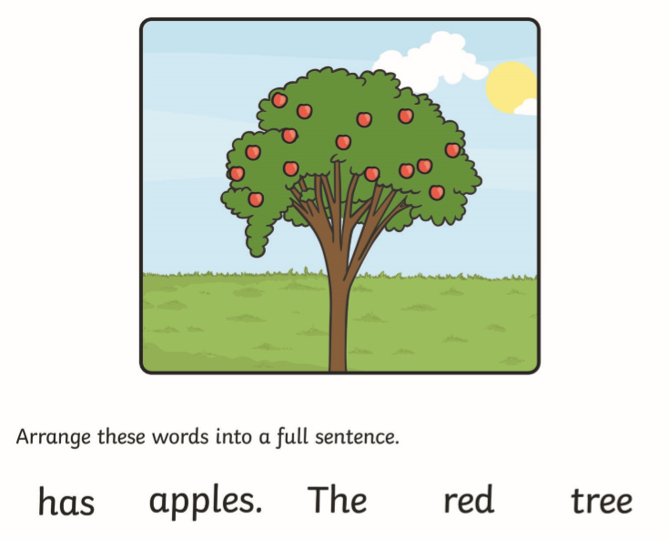

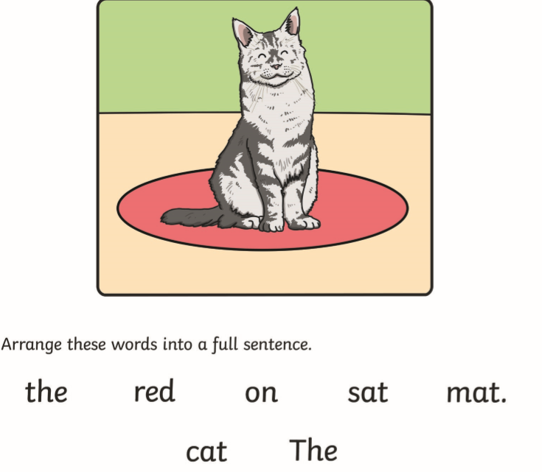

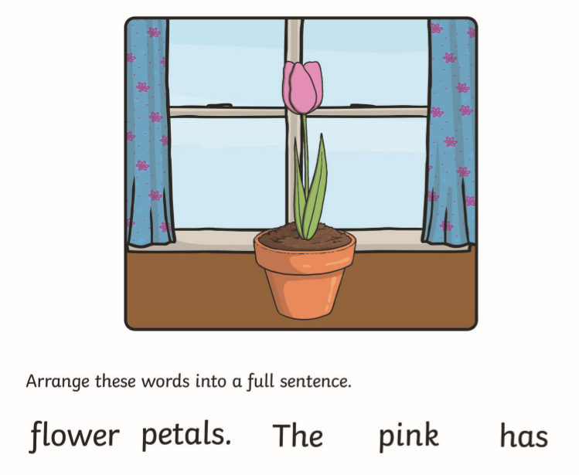

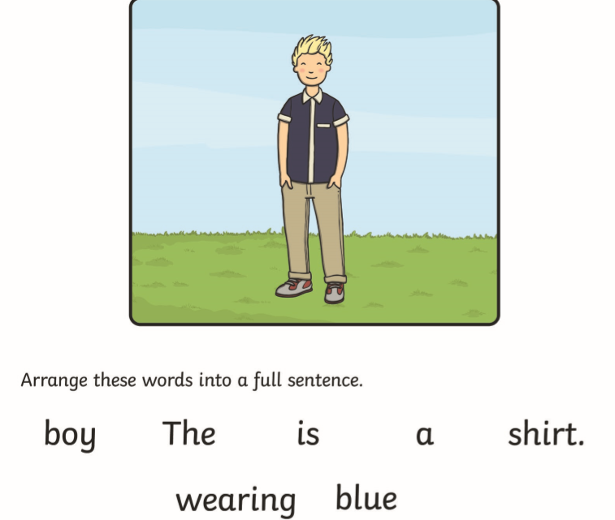

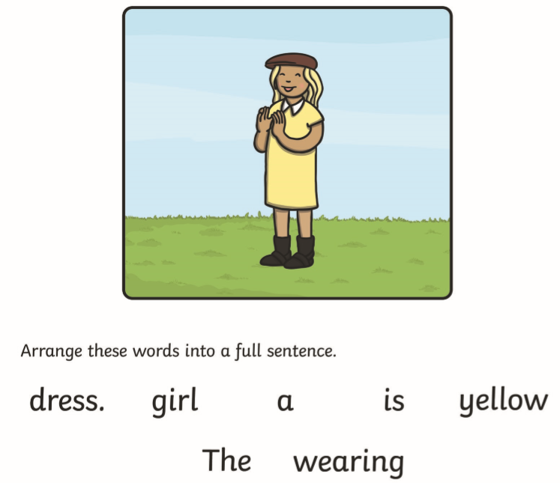

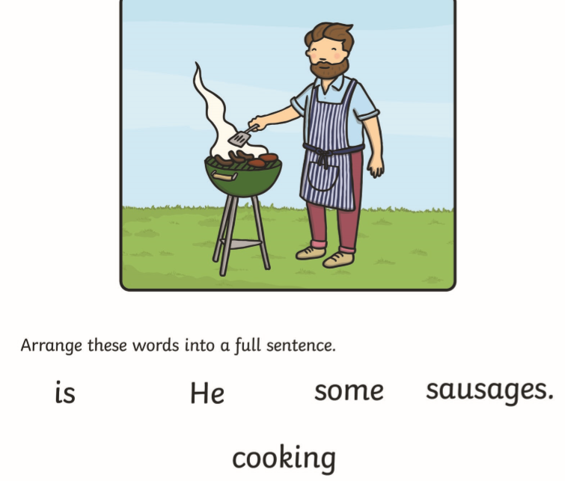

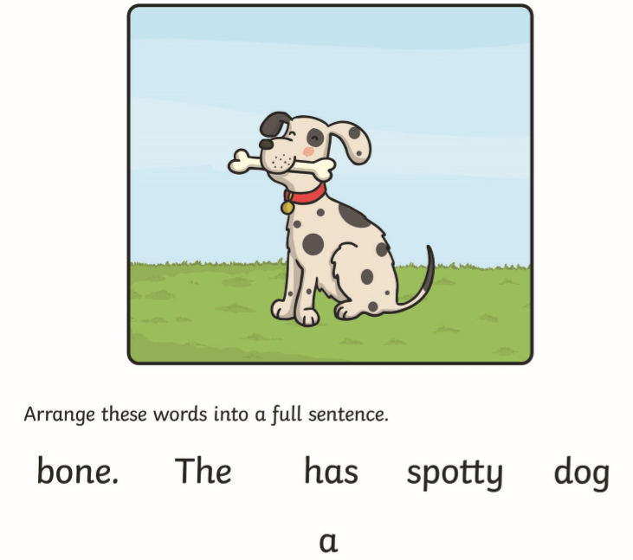

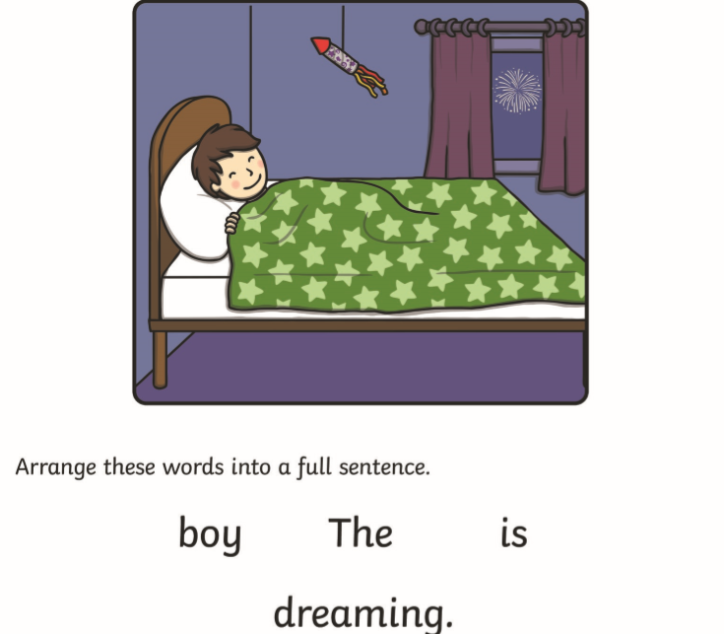

Activity 2- Look at the images. Write a sentence using a different opener to describe a hand washing routine. Some sentences have been given as a guide.

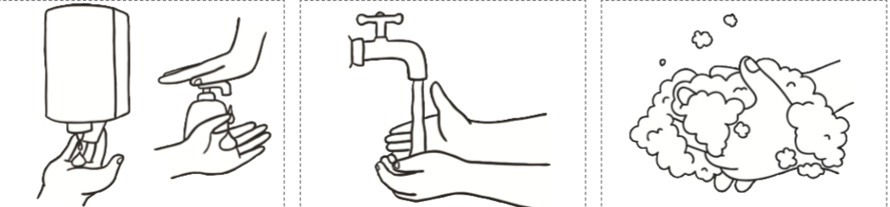
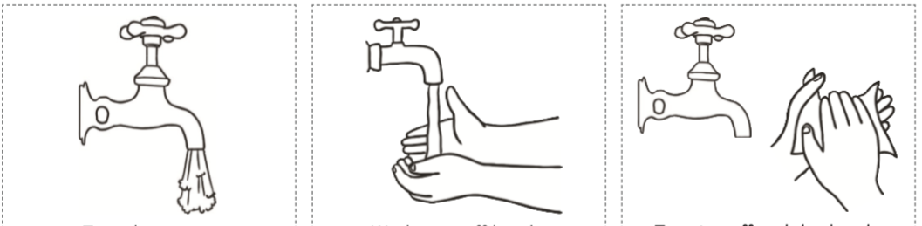

______________ turn on the tap.
______________ wet your hands under the running water.
______________ squirt the soap onto your hands.
______________ rub your hands together to create a lather, do this for 20 seconds.
______________ rinse the soap off under the running water.
______________ turn the tap off and dry your hands.

First | After that | Finally
A few moments later | Then | Next

Activity 3- Think about what a fact is. What makes a fact? Discuss together. Look at the image below. Write 3 facts about the picture. Remember it must be true. Challenge yourself by writing a sentence which is untrue about the image.
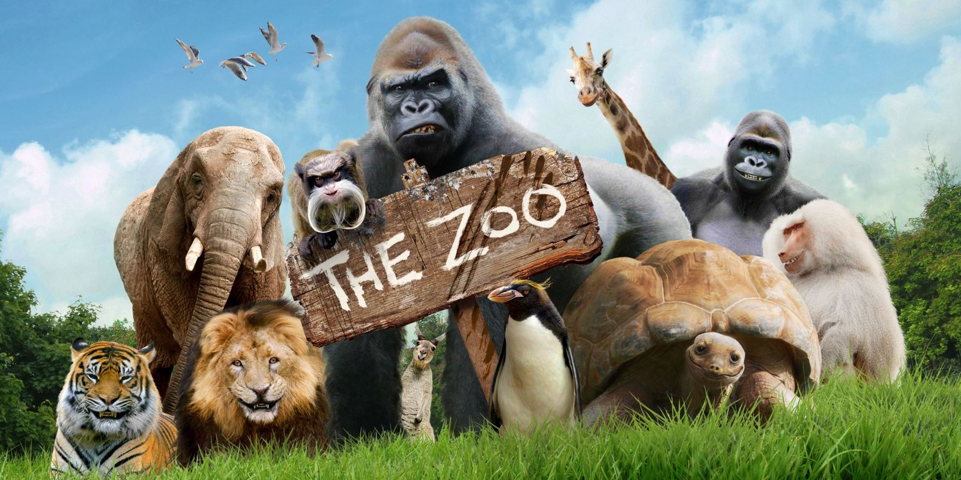
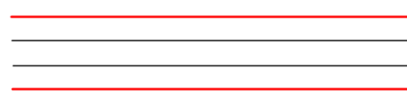
Challenge- Write a sentence that is not a fact.

Activity 4- Read the words in the table below. These are the present tense verbs (happening now). In the column next to the present tense verbs, write the past tense (have happened). Think about the how the spelling of the word changes. An example has been done for you.

Present tense | Past tense
Paint | Painted
Jump
Walk
Cook
Run
Eat

Now, use these words to create sentences. Can you think of any of your own verbs in the past and present tense?

