Teacher
Self
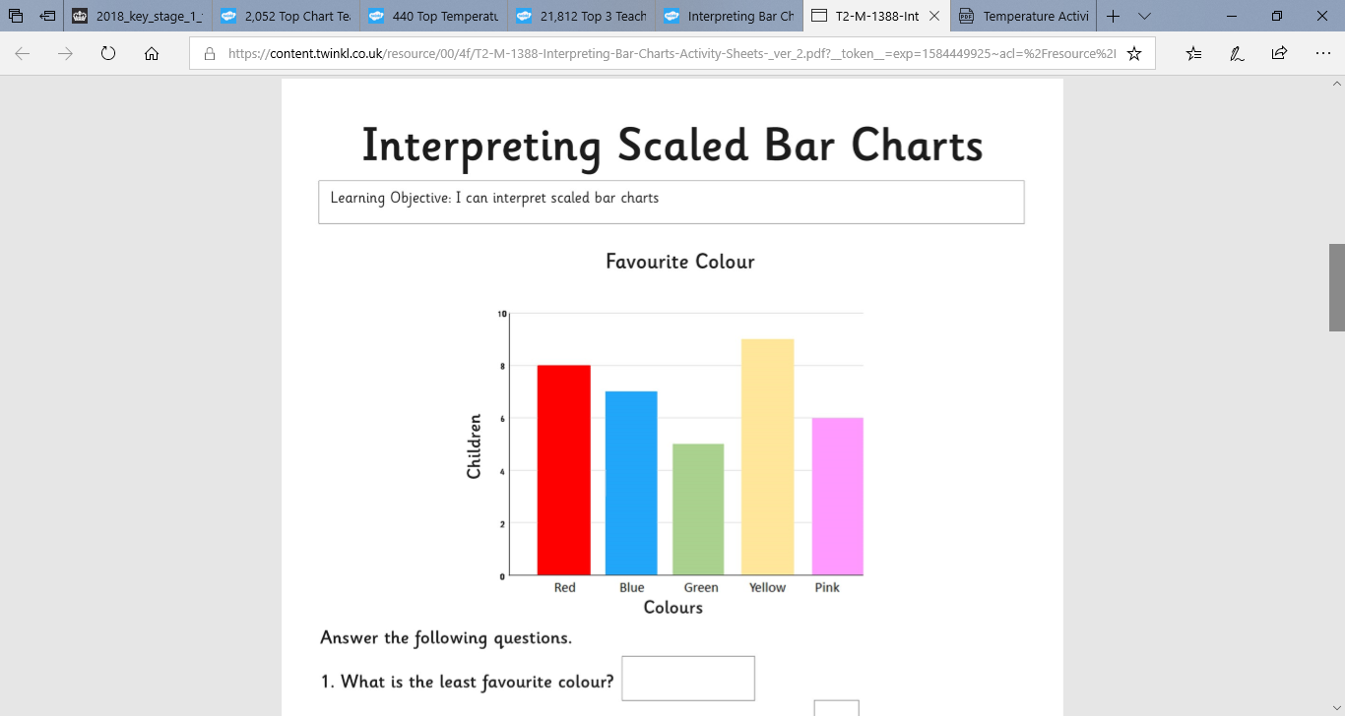
WALT: know how to read scales (yellow)

How many children voted for red?
How many children voted for blue?
How many children voted for green?
How many children voted for yellow?
How many children voted for pink?

