On the following pages, you will find a selection of activities linked to the English learning your child would have been completing at school this week. Please read the instructions carefully and complete the task with your child.
Thank you.

Activity 1- Complete a task that your child will be able to recount the following day. This could be baking a cake, making sandwiches or soup, completing a daily exercise or creating a sculpture using modelling materials. The activity can be indoors or in your garden, use your imagination to be as creative as possible. Afterwards, make some notes or discuss the activity you have completed.

Activity 2- Complete the following sheet with as much information from your activity as you can possibly remember. This is a plan so needs to be informative but does not need to be written in full sentences (save that for Activity 4.)
Temporal openers- time words linked to the order of something. For example: First, next, finally.
Amazing word choices- Words that make you go WOW! For example: meandered, flamboyant, sauntered.

Self- assessment
Peer assessment
Teacher/ Parent assessment


Title : ________________________________
What happened?
Introduction
Monday | Tuesday | Wednesday | Thursday | Friday
Conclusion
My favourite part…
AMAZING word choices.
A miniscule picture
Temporal Openers

Activity 3- Read your plan aloud as if you were writing it. For example, if you have written –Mixed flour, you could say, Next, we mixed the flour using a wooden spoon. When you have read your plan aloud move on to Activity 4.

Activity 4- Unaided writing. Without any help from your adult, write your recount on lined paper (provided below- remember to write in between the grey lines. Red lines are for long and tall letters.) If you are unable to print, use the paper in your home or type it on your computer. You may use your plan to support you with your writing. When you have finished, read it through with your adult and mark it using the marking scheme below:

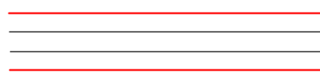

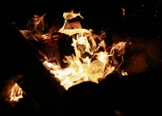
Date:
HOT write
WALT: Know the features of a recount.
Teacher Assessment. | Self-assessment | Teacher assessment
- I can write a title
- I can include a capital letter at the start of sentences
- I can write a sentence
- I can use a full stop to end the sentence
- I can write in the past tense as it has already happened
- I can write in chronological (time) order
- I can use temporal openers to start my sentences
- I can write fact- based information
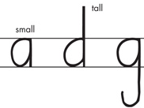 | 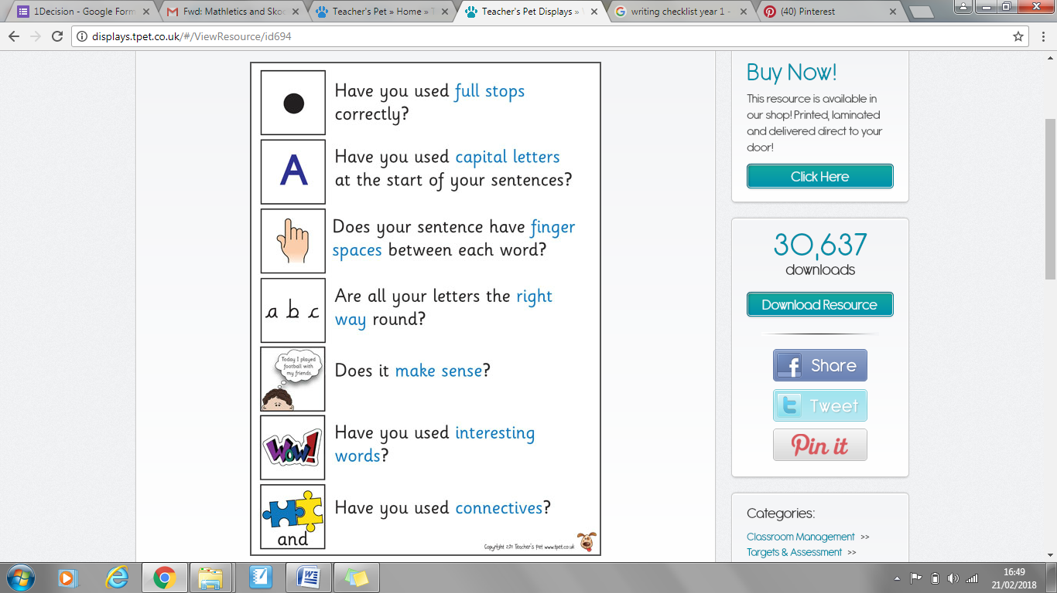 |  |  |  | 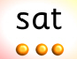
Writing on the line | Full Stop | Finger space | Capital Letter | Does it make sense? | Have you used your phonics skills?

Activity 5- Ask your adult to show you what a question mark is (?) Draw a question mark using felt tips, pencils, in sand, sky write it until you are able to form it yourself. Look at the pictures below and write a question for each one.

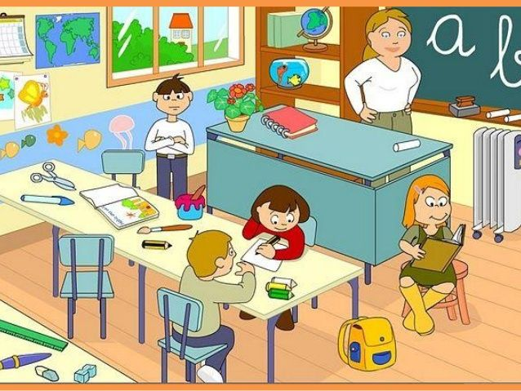
For example: What are the names of the fish?
