On the following pages, you will find a selection of activities linked to the English learning your child would have been completing at school this week. This term we are focussing on the story ‘The Gruffalo’ by Julia Donaldson. Please read the instructions carefully and complete the task with your child. If you would like to complete a range of independent ‘Gruffalo’ linked activities please do so as part of your extended home learning. We would love to see any photographs you may have taken. Please send them to the Beecroft office account so we can see what ideas you have thought of.
Thank you,
Mrs Brooks.

Activity 1- Unaided writing. Without any help from your adult, write a journey story on lined paper (provided below- remember to write in between the grey lines. Red lines are for long and tall letters.) If you are unable to print, use the paper in your home or type it on your computer. You may discuss with your adult what you think a journey story may be. When you have finished, read it through with your adult and mark it using the marking scheme below:
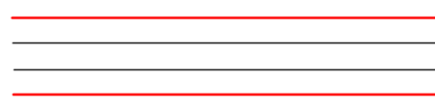
Date:
COLD write
WALT: Know the features of a journey story.
Teacher Assessment. | Self-assessment | Teacher assessment
- I can begin my story by introducing the characters
- I can ensure one event leads to the next.
- I can write as if the characters were going on a journey.
- I have used direct speech.
- I have used adjectives to describe.
- I have used a capital letter at the beginning of each sentence.
- I have used a full stop at the end of each sentence.
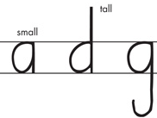 | 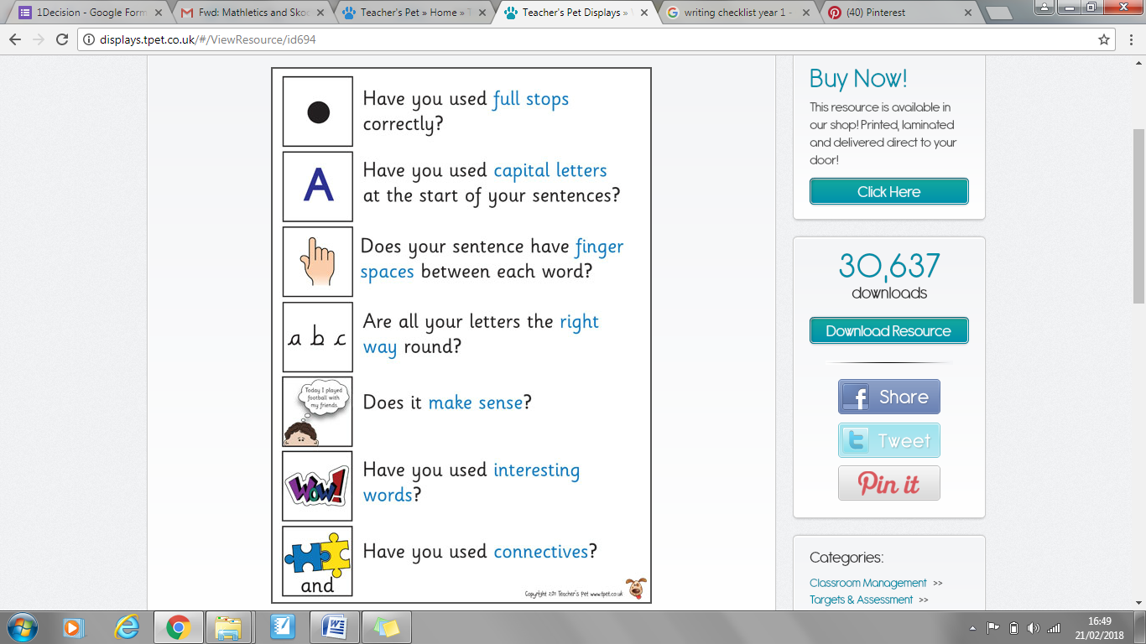 |  |  |  | 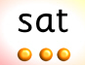
Writing on the line | Full Stop | Finger space | Capital Letter | Does it make sense? | Have you used your phonics skills?

Activity 2- If you have the story ‘The Gruffalo’ by Julia Donaldson, read this with your adult. If you do not have a copy, watch the short film based on the book. ‘The Gruffalo’ is available on BBC iPlayer.
https://www.bbc.co.uk/programmes/b00pk64x
When you have watched, read or completed both write some questions linked to the story.
For example: What colour is the wart on the end of the Gruffalo’s nose?
Where does the Fox live?
Ask your adult if they know the answers or ask them to ask you the questions.

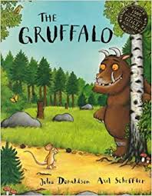

Activity 3- Re-tell the story, ‘The Gruffalo’ by Julia Donaldson to your adult.
Together, write down a list of all the characters in the story. When you have done this, act out as many of the characters as you are able. Can your adult guess which character you are?
If you have a camera, freeze-frame different scenes in the story. Get an adult to take a photograph and send it to us at Beecroft Academy.
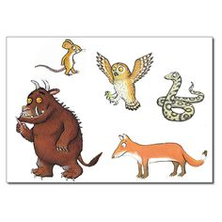

Activity 4- Discuss with your adult what an adjective is (a word which is used to describe. For example: bright, terrifying, smooth) Write down as many as you can. Read the instructions on the sheet below and complete as much as you are able.

Self assessment
Peer assessment
Teacher assessment
Date: __________________
WALT: Know an adjective is used to describe
