Day of the week | Tuesday | Wednesday | Thursday | Friday
Topic activity | Create a den using a variety of materials in your house. Upload a photo to Tapestry for your teacher to see your den. | Fold up the washing and put the washing away. | Engage in some water play. Have some different containers. Which one holds the most water – why? | Play with your favourite toys with your adult.
Morning activity | Practise writing your full name. Start your letters in the correct place. | Create a number line from 0-20. Can you find the right number of objects for each number? | Make some playdoh with your adult and show them some Dough Disco moves. | Draw a picture of your family and label using your phonics.
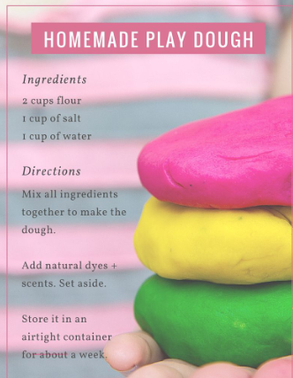
EYFS Topic Activities Week Beginning 21.04.2020

